CO1 AT2 Application-Based Questions
B.SHASHANK
192324123
9. Weather Data Processing:-
Aim
To read weather data from a CSV file, find the highest and lowest temperatures, calculate the average rainfall, display days with rainfall greater than 100 mm, and save the processed data.
weather.csv
Day,Temperature,Rainfall
Monday,32,50
Tuesday,35,120
Wednesday,30,80
Thursday,38,150
Friday,33,60
Saturday,29,110
Sunday,31,40
Code
import pandas as pd

# Read CSV file
weather = pd.read_csv("weather.csv")

print("Weather Data")
print(weather)

# Highest temperature
print("\nHighest Temperature:")
print(weather["Temperature"].max())

# Lowest temperature
print("\nLowest Temperature:")
print(weather["Temperature"].min())

# Average rainfall
print("\nAverage Rainfall:")
print(weather["Rainfall"].mean())

# Rainfall greater than 100 mm
print("\nDays with Rainfall Greater Than 100 mm")
print(weather[weather["Rainfall"] > 100])
OUTPUT:
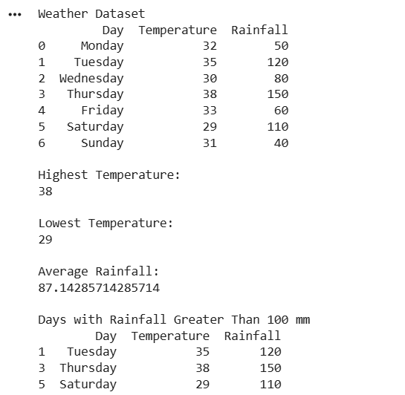
Result
- Highest and lowest temperatures are displayed.
- Average rainfall is calculated.
- Days with rainfall greater than 100 mm are displayed successfully.

10. University Admission Data
Aim
To identify duplicate student records, remove duplicate entries, display students admitted to the CSE department, and save the updated dataset.
admissions.csv
StudentID,Name,Department
101,Alice,CSE
102,Bob,ECE
103,Charlie,CSE
104,David,MECH
102,Bob,ECE
105,Eva,CSE
103,Charlie,CSE
Code
import pandas as pd

# Read CSV file
admissions = pd.read_csv("admissions.csv")

print("Original Dataset")
print(admissions)

# Identify duplicate records
print("\nDuplicate Records")
print(admissions[admissions.duplicated()])

# Remove duplicate entries
admissions = admissions.drop_duplicates()

print("\nDataset After Removing Duplicates")
print(admissions)

# Display CSE students
print("\nStudents Admitted to CSE Department")
print(admissions[admissions["Department"] == "CSE"])

# Save updated dataset
admissions.to_csv("Updated_Admissions.csv", index=False)

print("\nUpdated dataset saved successfully.")
OUTPUT:
Admission Dataset
StudentID Name Department
0 101 Alice CSE
1 102 Bob ECE
2 103 Charlie CSE
3 104 David MECH
4 102 Bob ECE
5 105 Eva CSE
6 106 Rahul EEE
7 107 Priya CIVIL
8 103 Charlie CSE
9 108 Anil CSE
10 109 Kiran ECE
11 110 Sneha CSE

Duplicate Records
StudentID Name Department
4 102 Bob ECE
8 103 Charlie CSE

Dataset After Removing Duplicates
StudentID Name Department
0 101 Alice CSE
1 102 Bob ECE
2 103 Charlie CSE
3 104 David MECH
5 105 Eva CSE
6 106 Rahul EEE
7 107 Priya CIVIL
9 108 Anil CSE
10 109 Kiran ECE
11 110 Sneha CSE

Students Admitted to CSE Department
StudentID Name Department
0 101 Alice CSE
2 103 Charlie CSE
5 105 Eva CSE
9 108 Anil CSE
11 110 Sneha CSE

Updated dataset saved successfully.
Result
- Duplicate student records are identified.
- Duplicate entries are removed.
- Students admitted to the CSE department are displayed.
- The updated dataset is saved as Updated_Admissions.csv successfully.

